Type or Paste the Title of Your Article Here

Abstract: Type or paste your abstract here considering the journal’s instructions for authors. Type or paste your abstract here considering the journal’s instructions for authors. Type or paste your abstract here considering the journal’s instructions for authors. Type or paste your abstract here considering the journal’s instructions for authors. Type or paste your abstract here considering the journal’s instructions for authors. Type or paste your abstract here considering the journal’s instructions for authors. Type or paste your abstract here considering the journal’s instructions for authors. Type or paste your abstract here considering the journal’s instructions for authors. Type or paste your abstract here considering the journal’s instructions for authors. Type or paste your abstract here considering the journal’s instructions for authors.

Keywords: Keyword1, Keyword2, Keyword3, Keyword4 (if any), Keyword5 (if any)

1. Use This Style for Level One Headings
First Paragraph: use this for the first paragraph in a section.
New paragraph: use this style for beginning a new paragraph.
• For bulleted lists
(1) For numbered lists
1.1. Use this style for level two headings
1.1.1. Use this style for level three headings
Figures should be legible and put exactly where they should be in the main text. For the figures, use the following format.
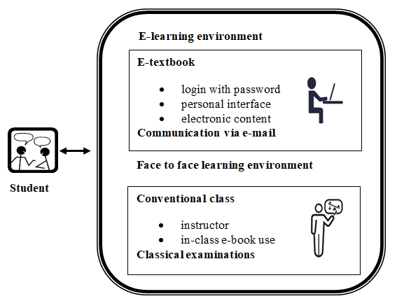
Figure 1. Structure of the blended learning environment arranged for experimental group

Tables should be editable and must be at an appropriate place in the main text such as figures. For the tables, use the following format.
Table 1. Intra-group comparison of attitude scores
 | Attitude | N | $$\overline{X}$$ | Ss | t | p
Experimental Group | Pre-course attitude | 33 | 2.99 | 0.463 | -2.16 | .038
 | Post-course attitude | 33 | 3.13 | 0.465
Control Group | Pre-course attitude | 31 | 2.96 | 0.31 | -0.53 | .599
 | Post-course attitude | 31 | 3.00 | 0.36

References
References should be prepared considering the APA 7 format. See the sample references below. You can find the detail information on https://owl.purdue.edu/owl/research_and_citation/apa_style/apa_style_introduction.html

Brusilovsky, P. Chavan, G., & Farzan, R. (2004). Social adaptive navigation support for open corpus electronic textbooks. Adaptive Hypermedia and Adaptive Web-Based Systems, 3137, 24–33.
Cottrell, D. M., & Robinson, R. A. (2003). Blending learning in an accounting course, The Quarterly Review of Distance Education, 4(3), 261–269.
Graham, C. R. (2005). Blended learning systems: definition, current trends, and future directions, The handbook of blended learning global perspectives. Pfeiffer Publishing.
Güler, M., Çekmez, E., & Çelik, D. (2020). Breaking with tradition: An investigation of an alternative instructional sequence designed to improve prospective teachers’ noticing skills. Teaching and Teacher Education, 92, 103073. https://doi.org/10.1016/j.tate.2020.103073

